Experiment 1
Aim: Practice of LEX/YACC of compiler writing
Theory:
LEX is a tool used to generate lexical analyzers, the first phase of a compiler. It takes a source file containing regular expressions and their associated actions, written in a file with a .l extension, and translates it into a C program (lex.yy.c) that recognizes those patterns in an input stream. Each recognized pattern is called a token, and the generated scanner reads characters from the input, groups them into these tokens based on the rules defined, and passes them on to later stages of the compiler such as the parser. A LEX program is organized into three sections separated by %%: the definitions section for declarations and options, the rules section containing the actual patterns and actions, and the user subroutines section for supporting C functions like main(). Internally, LEX follows the longest-match rule, meaning it always picks the longest string that matches any rule, and if two rules match the same length, the one defined first in the file wins. This makes LEX efficient for building scanners without having to hand-write the matching logic in raw C.
Practice Questions
1. Write a program to construct a small calculator that can add, subtract, multiply and divide in LEX.
Code:
%{
#include <stdio.h>
#include <stdlib.h>
float num1, num2, result;
char op;
%}
%%
[0-9]+"."[0-9]+ { num2 = atof(yytext); }
[0-9]+ { num2 = atof(yytext); }
[+\-*/] { op = yytext[0]; num1 = num2; }
\n {
switch(op) {
case '+': result = num1 + num2; break;
case '-': result = num1 - num2; break;
case '*': result = num1 * num2; break;
case '/': result = num1 / num2; break;
}
printf("The Answer = %f\n", result);
}
%%
int main() {
yylex();
return 0;
}
int yywrap() {
return 1;
}
Output:
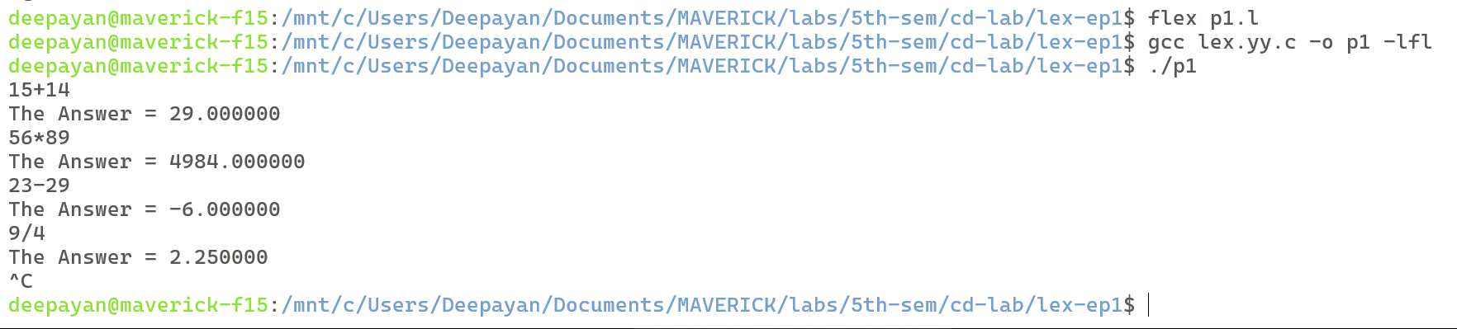
2. Write a program to match a string in LEX.
Code:
%{
#include <stdio.h>
int flag = 0;
%}
%%
"hello" { flag = 1; }
. { }
\n {
if (flag)
printf("String matched\n");
else
printf("String not matched\n");
flag = 0;
}
%%

int main() {
yylex();
return 0;
}

int yywrap() {
return 1;
}
Output:
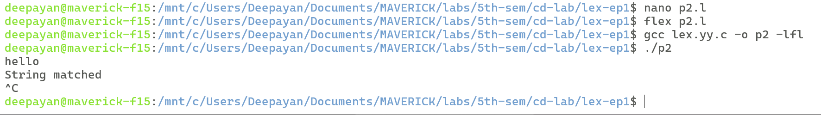
3. Write a LEX program to count the number of vowels and consonants in a given string.
Code:
%{
#include <stdio.h>
int vowels = 0, consonants = 0;
%}

%%
[aeiouAEIOU] { vowels++; }
[a-zA-Z] { consonants++; }
.|\n { }
%%

int main() {
printf("Enter a string: ");
yylex();
printf("Number of vowels = %d\n", vowels);
printf("Number of consonants = %d\n", consonants);
return 0;
}

int yywrap() {
return 1;
}
Output:
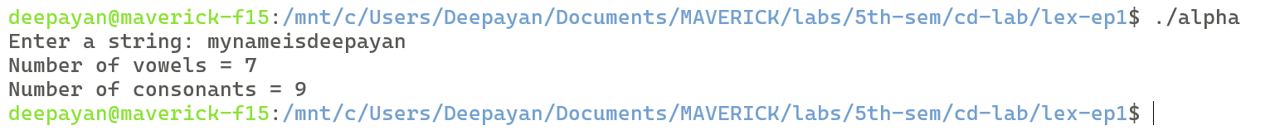

Experiment 2
Aim: Write a program to check whether a string belong to the grammar or not
Theory:
A Context-Free Grammar (CFG) is a formal way of defining the syntax of a language using a set of production rules that describe how strings can be generated from a start symbol. Each rule has the form A → α, where A is a non-terminal and α is a string of terminals and/or non-terminals, and rules can be applied repeatedly and in any order to derive valid strings of the language. Checking whether a given string belongs to a CFG means determining if there exists some sequence of rule applications, starting from S, that produces exactly that string. For simple grammars like the ones here, this membership can often be checked directly by recognizing the structural pattern the recursion produces, rather than building a full parse tree: for example, aSb-type recursion nested around a base case naturally generates strings with equal numbers of a's and b's, while symmetric recursion like aSa/bSb generates palindromes. CFGs form the basis of the syntax analysis (parsing) phase of a compiler, where the parser checks whether the token stream produced by the lexical analyzer conforms to the grammar of the programming language.
Practice Questions
1. Write a program to check whether a string belong to a grammar or not.
a) S -> aS
S -> Sb
S -> ab
String of the form : aab

b) S -> aSa
S -> bSb
S -> a
S -> b
The Language generated is : All Odd Length Palindromes

c) S -> aSbb
S -> abb
The Language generated is : anb2n , where n>1

d) S -> aSb
S -> ab
The Language generated is : anbn, where n>0
Code:
#include <iostream>
#include <string>
using namespace std;

bool checkA(string s) {
int n = s.length();
int i = 0;
while (i < n && s[i] == 'a') i++;
if (i == 0) return false;
int firstB = i;
while (i < n && s[i] == 'b') i++;
if (i != n) return false;
if (i == firstB) return false;
return true;
}

bool checkB(string s) {
int n = s.length();
if (n % 2 == 0) return false;
int i = 0, j = n - 1;
while (i < j) {
if (s[i] != s[j]) return false;
i++; j--;
}
return true;
}

bool checkC(string s) {
int n = s.length();
int i = 0;
while (i < n && s[i] == 'a') i++;
int countA = i;
if (countA == 0) return false;
int j = i;
while (j < n && s[j] == 'b') j++;
int countB = j - i;
if (j != n) return false;
return countB == 2 * countA;
}

bool checkD(string s) {
int n = s.length();
int i = 0;
while (i < n && s[i] == 'a') i++;
int countA = i;
if (countA == 0) return false;
int j = i;
while (j < n && s[j] == 'b') j++;
int countB = j - i;
if (j != n) return false;
return countA == countB;
}
int main() {
string s;
cout << "Enter string: ";
cin >> s;
bool matched = false;
if (checkA(s)) {
cout << s << " belongs to Grammar 1 (S -> aS | Sb | ab)\n";
matched = true;
}
if (checkB(s)) {
cout << s << " belongs to Grammar 2 (S -> aSa | bSb | a | b)\n";
matched = true;
}
if (checkC(s)) {
cout << s << " belongs to Grammar 3 (S -> aSbb | abb)\n";
matched = true;
}
if (checkD(s)) {
cout << s << " belongs to Grammar 4 (S -> aSb | ab)\n";
matched = true;
}
if (!matched)
cout << s << " does not belong to any of the given grammars\n";
return 0;
}

Output:
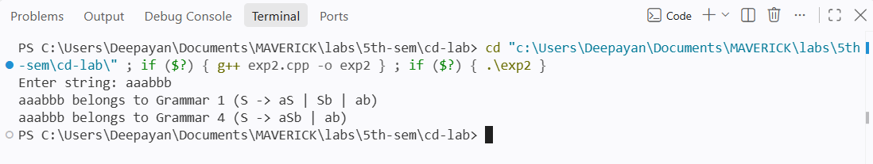
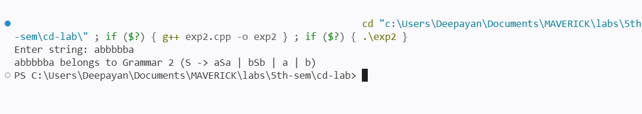

Experiment 3
Aim: Write a program to check whether a string include keyword or not.
Theory:
A keyword is a reserved word in a programming language that has a fixed, predefined meaning and cannot be used as an identifier, such as int, if, while, or return. An identifier, on the other hand, is a name chosen by the programmer to represent variables, functions, or other user-defined entities, and must not clash with any keyword. Identifying keywords in source code is one of the basic tasks of a lexical analyzer, since recognizing them correctly is what allows the compiler to distinguish language constructs (like control statements) from ordinary variable names. In practice, this is done by first checking whether a scanned token matches any entry in a fixed table of reserved words; if it does, it's classified as a keyword, and if not, it's treated as an identifier. Programs that count keyword occurrences in a paragraph, classify a single word, or total the number of keywords in a sentence all rely on this same core lookup: breaking the input into individual words (tokens) and comparing each one against the keyword list.
Practice Questions
- Write a program to identify and count the occurrences of keywords in a given input string/paragraph.
Code:
#include <iostream>
#include <vector>
#include <string>
#include <map>
using namespace std;

vector<string> keywords = {
"int","float","double","char","if","else","for","while","do",
"switch","case","break","continue","return","void","struct",
"static","const"
};

bool isKeyword(const string &word) {
for (const string &k : keywords) {
if (word == k) return true;
}
return false;
}

vector<string> tokenize(const string &text) {
vector<string> tokens;
string current = "";
for (char c : text) {
if (isalnum(c) || c == '_') {
current += c;
} else {
if (!current.empty()) {
tokens.push_back(current);
current = "";
}
}
}
if (!current.empty()) tokens.push_back(current);
return tokens;
}

int main() {
string paragraph;
cout << "Enter a paragraph: ";
getline(cin, paragraph);

map<string, int> counts;
for (const string &token : tokenize(paragraph)) {
if (isKeyword(token)) counts[token]++;
}

for (const auto &pair : counts) {
cout << pair.first << " : " << pair.second << "\n";
}

return 0;
}
Output:
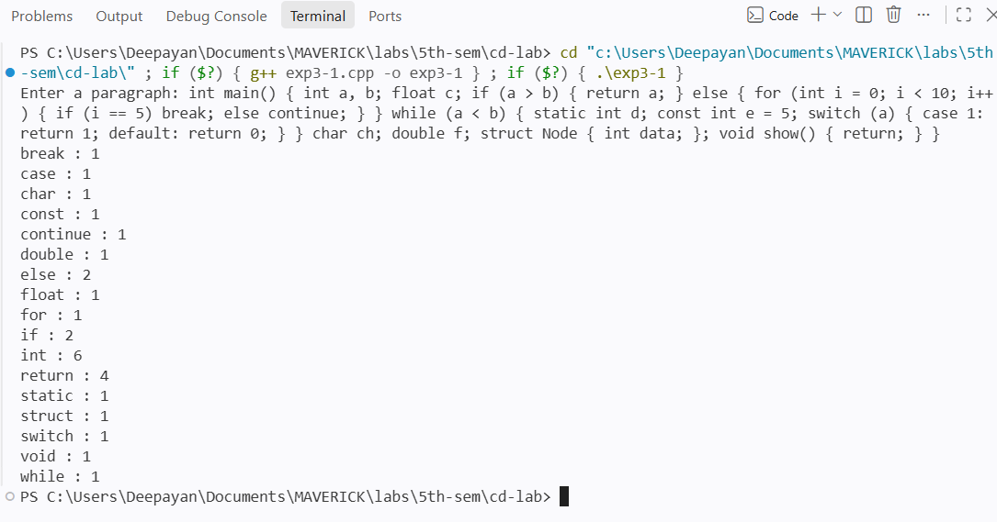
- Write a program to check whether a given word is a keyword or an identifier.
Code:
#include <iostream>
#include <vector>
#include <string>
using namespace std;

vector<string> keywords = {
"int","float","double","char","if","else","for","while","do",
"switch","case","break","continue","return","void","struct",
"static","const"
};

bool isKeyword(const string &word) {
for (const string &k : keywords) {
if (word == k) return true;
}
return false;
}

int main() {
string word;
cout << "Enter a word: ";
cin >> word;

if (isKeyword(word))
cout << word << " is a keyword\n";
else
cout << word << " is an identifier\n";

return 0;
}

Output:
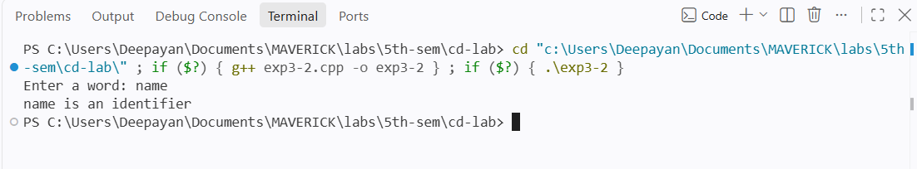
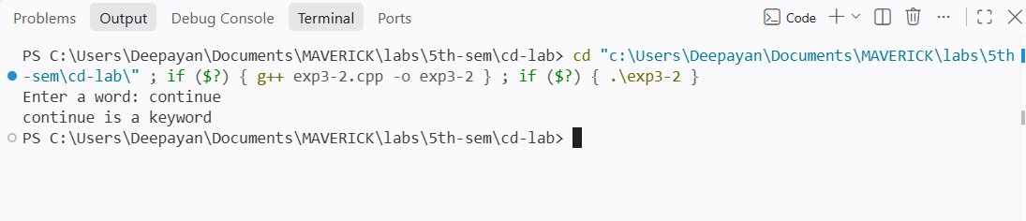
- Write a program to count the number of keywords in a given sentence.
Code:
#include <iostream>
#include <vector>
#include <string>
using namespace std;

vector<string> keywords = {
"int","float","double","char","if","else","for","while","do",
"switch","case","break","continue","return","void","struct",
"static","const"
};

bool isKeyword(const string &word) {
for (const string &k : keywords) {
if (word == k) return true;
}
return false;
}

vector<string> tokenize(const string &text) {
vector<string> tokens;
string current = "";
for (char c : text) {
if (isalnum(c) || c == '_') {
current += c;
} else {
if (!current.empty()) {
tokens.push_back(current);
current = "";
}
}
}
if (!current.empty()) tokens.push_back(current);
return tokens;
}

int main() {
string sentence;
cout << "Enter a sentence: ";
getline(cin, sentence);

int count = 0;
for (const string &token : tokenize(sentence)) {
if (isKeyword(token)) count++;
}

cout << "Number of keywords = " << count << "\n";
return 0;
}
Output:
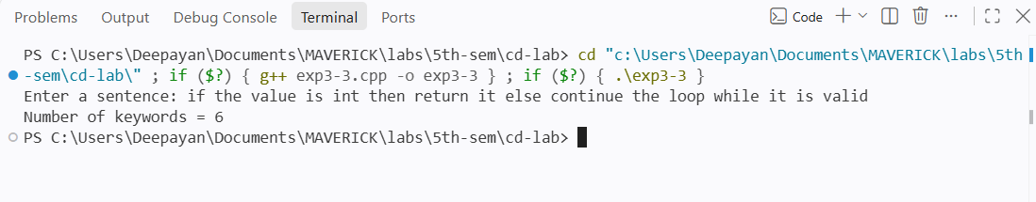

Experiment 4
Aim: Write a program to remove Left Recursion from a Grammar
Theory:
A grammar is said to have left recursion when a non-terminal A has a production of the form A → Aα, meaning the derivation of A begins by referring back to A itself. This is a problem for top-down parsers (like recursive-descent or LL parsers), because trying to expand A leads straight back to expanding A again, causing infinite recursion without ever consuming any input. Left recursion is removed by rewriting productions of the form A → Aα₁ | Aα₂ | ... | β₁ | β₂ | ... (where the β's don't start with A) into a right-recursive equivalent: A → β₁A' | β₂A' | ... and A' → α₁A' | α₂A' | ... | ε, where A' is a newly introduced non-terminal and ε denotes the empty string. This transformation preserves the language generated by the grammar while eliminating the immediate left recursion, making the grammar suitable for predictive parsing techniques used in the syntax-analysis phase of a compiler.
Code:
#include <iostream>
#include <string>
#include <vector>
using namespace std;

vector<string> splitAlternatives(const string &rhs) {
vector<string> parts;
string current = "";
for (char c : rhs) {
if (c == '|') {
parts.push_back(current);
current = "";
} else {
current += c;
}
}
parts.push_back(current);
return parts;
}

void removeLeftRecursion(const string &production) {
int arrowPos = production.find("->");
string lhs = production.substr(0, arrowPos);
string rhs = production.substr(arrowPos + 2);

vector<string> alternatives = splitAlternatives(rhs);
vector<string> alpha, beta;

for (const string &alt : alternatives) {
if (alt.substr(0, lhs.length()) == lhs) {
alpha.push_back(alt.substr(lhs.length()));
} else {
beta.push_back(alt);
}
}

if (alpha.empty()) {
cout << production << " (no left recursion)\n";
return;
}

string newNonTerminal = lhs + "'";

cout << lhs << " -> ";
for (size_t i = 0; i < beta.size(); i++) {
cout << beta[i] << newNonTerminal;
if (i != beta.size() - 1) cout << " | ";
}
cout << "\n";

cout << newNonTerminal << " -> ";
for (size_t i = 0; i < alpha.size(); i++) {
cout << alpha[i] << newNonTerminal << " | ";
}
cout << "e\n";
}

int main() {
int n;
cout << "Enter number of productions: ";
cin >> n;
cin.ignore();

for (int i = 0; i < n; i++) {
string production;
cout << "Enter production " << (i + 1) << " (format A->Aa|Ab|c): ";
getline(cin, production);
removeLeftRecursion(production);
}

return 0;
}
Output:
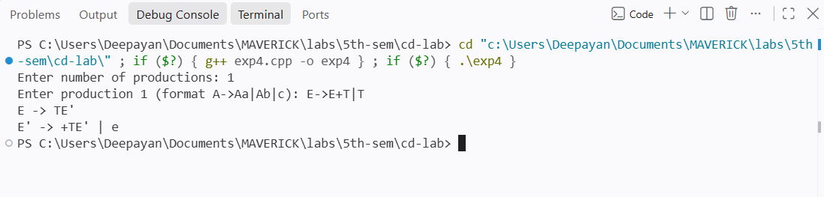

Experiment 5
Aim: Write a programm to perform Left Factoring on a Grammar
Theory:
Left factoring is a grammar transformation used when two or more productions of the same non-terminal share a common prefix, such as A → αβ₁ | αβ₂ | ... , where α is the shared prefix. In this situation, a top-down parser looking at the input cannot decide which production to apply just by seeing the first few symbols, since more than one alternative starts the same way — this ambiguity in choice is what makes the grammar unsuitable for predictive (LL) parsing. Left factoring resolves this by factoring out the common prefix into a single production and deferring the choice to a new non-terminal: A → αA', A' → β₁ | β�2 | ... , where A' is newly introduced. This delays the decision until enough of the input has been seen to distinguish between the alternatives, without changing the language the grammar generates. Along with removal of left recursion, left factoring is one of the standard grammar transformations applied before constructing a predictive parser in the syntax-analysis phase of a compiler.
Code:
#include <iostream>
#include <string>
#include <vector>
#include <map>
using namespace std;

vector<string> splitAlternatives(const string &rhs) {
vector<string> parts;
string current = "";
for (char c : rhs) {
if (c == '|') {
parts.push_back(current);
current = "";
} else {
current += c;
}
}
parts.push_back(current);
return parts;
}

string longestCommonPrefix(const vector<string> &group) {
string prefix = group[0];
for (size_t i = 1; i < group.size(); i++) {
int j = 0;
while (j < (int)prefix.length() && j < (int)group[i].length() && prefix[j] == group[i][j]) {
j++;
}
prefix = prefix.substr(0, j);
}
return prefix;
}

void leftFactor(const string &production) {
int arrowPos = production.find("->");
string lhs = production.substr(0, arrowPos);
string rhs = production.substr(arrowPos + 2);

vector<string> alternatives = splitAlternatives(rhs);

map<char, vector<string>> groups;
vector<char> order;
for (const string &alt : alternatives) {
char firstChar = alt.empty() ? '\0' : alt[0];
if (groups.find(firstChar) == groups.end()) {
order.push_back(firstChar);
}
groups[firstChar].push_back(alt);
}

vector<string> mainAlternatives;
vector<string> newProductions;
int counter = 1;

for (char c : order) {
vector<string> &group = groups[c];
if (group.size() == 1) {
mainAlternatives.push_back(group[0]);
} else {
string prefix = longestCommonPrefix(group);
string newNonTerminal = lhs + string(counter, '\'');
counter++;
mainAlternatives.push_back(prefix + newNonTerminal);

string newProd = newNonTerminal + " -> ";
for (size_t i = 0; i < group.size(); i++) {
string suffix = group[i].substr(prefix.length());
if (suffix.empty()) suffix = "e";
newProd += suffix;
if (i != group.size() - 1) newProd += " | ";
}
newProductions.push_back(newProd);
}
}

cout << lhs << " -> ";
for (size_t i = 0; i < mainAlternatives.size(); i++) {
cout << mainAlternatives[i];
if (i != mainAlternatives.size() - 1) cout << " | ";
}
cout << "\n";

for (const string &np : newProductions) {
cout << np << "\n";
}
}
int main() {
int n;
cout << "Enter number of productions: ";
cin >> n;
cin.ignore();
for (int i = 0; i < n; i++) {
string production;
cout << "Enter production " << (i + 1) << " (format A->aB|aC|b): ";
getline(cin, production);
leftFactor(production);
}
return 0;
}
Output:
